DATA ANALYTICS AND VISUALIZATION
6. Data analytics and Visualization with Python
6.1 Essential Data Libraries for data analytics: Pandas, NumPy, SciPy. Plotting and visualization with python: Introduction to Matplotlib, Basic Plotting with Matplotlib, Create Histogram, Bar Chart, Pie chart, Box Plot, violin plot using Matplotlib.
6.2 Introduction to seaborn Library, Multiple Plots, Regression plot, reg plot.
PAST QUESTIONS:
- Difference between Pandas and NumPy. (M23)
- Seaborn library. (M23)
- What is Pandas? State and explain key features of Pandas. (D23, D24)
- Difference between Matplotlib and Seaborn library. (M24)
- Explain different types of data visualisation in Python programming language. (M24)
- Pandas library. (M24)
- Explain following data visualization libraries in Python: Box plot, Violin plot, Pie chart, Histogram, Bar chart. (D24)

NOTES:

*Pandas :-
Pandas is open-source Python library which is used for data manipulation and analysis. It consist of data structures and functions to perform efficient operations on data. It is well-suited for working with tabular data such as spreadsheets or SQL tables. It is used in data science because it works well with other important libraries. It is built on top of the NumPy library as it makes easier to manipulate and analyze.
Features –
- Data Cleaning, Merging and Joining: Clean and combine data from multiple sources, handling inconsistencies and duplicates.
- Handling Missing Data: Manage missing values (NaN) in both floating and non-floating point data.
- Column Insertion and Deletion: Easily add, remove or modify columns in a DataFrame.
- Group By Operations: Use “split-apply-combine” to group and analyze data.
- Data Visualization: Create visualizations with Matplotlib and Seaborn, integrated with Pandas.

*NumPy :-
NumPy (Numerical Python) is a fundamental library for Python numerical computing. It provides efficient multi-dimensional array objects and various mathematical functions for handling large datasets making it a critical tool for professionals in fields that require heavy computation.

*Seaborn :-
Seaborn is an amazing visualization library for statistical graphics plotting in Python. It provides beautiful default styles and colour palettes to make statistical plots more attractive. It is built on top matplotlib library and is also closely integrated with the data structures from pandas.

*Matplotlib :-
Matplotlib is a powerful and versatile open-source plotting library for Python, designed to help users visualize data in a variety of formats. Developed by John D. Hunter in 2003, it enables users to graphically represent data, facilitating easier analysis and understanding.

*Visualization with Python :-
- Box plot - The statistical summary of the given data is presented graphically using a boxplot. A boxplot depicts information like the minimum and maximum data point, the median value, first and third quartile, and interquartile range.
Libraries – Matplotlib, Seaborn
Function – plt.boxplot(), sns.boxplot()
- Violin plot - A Violin Plot is a data visualization that combines the features of a box plot and a kernel density plot. It shows the distribution, probability density, and summary statistics (like median and interquartile range) of a numeric variable.
Libraries – Seaborn
Function – sns.violinplot()
- Pie chart - A Pie Chart is a circular statistical graphic that is divided into slices to illustrate numerical proportions. Each slice represents a category’s contribution to the whole.
Libraries – Matplotlib
Function – plt.pie()
- Histogram - A histogram is a graphical representation commonly used to visualize the distribution of numerical data. It divides the values within a numerical variable called as “bins”.
Libraries – Matplotlib, Seaborn
Function – plt.hist(), sns.histplot()
- Bar chart - A Bar Chart is a type of graph that represents categorical data with rectangular bars. Each bar's height (or length) corresponds to the value or frequency of the category it represents.
Libraries – Matplotlib, Seaborn
Function – plt.bar(), sns.barplot()

*Pandas vs NumPy :-
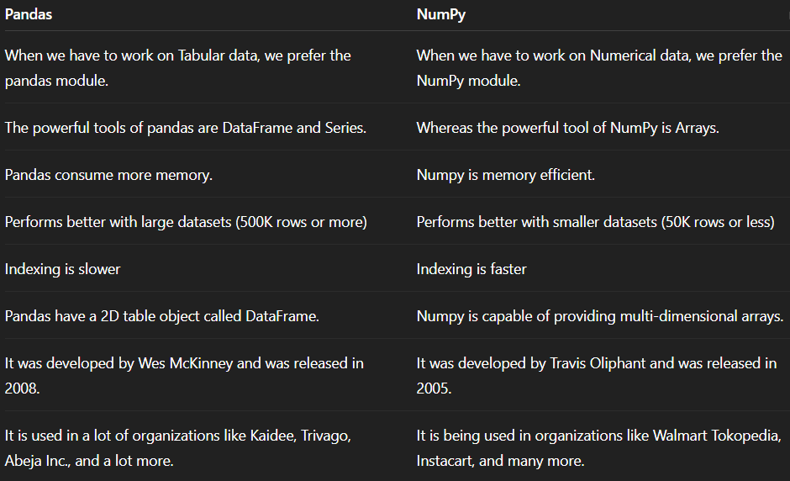
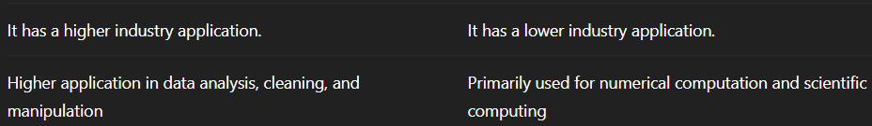

*Matplotlib vs Seaborn :-
